**Nubra Valley, Ladakh**

**Nubra**, also called **Dumra**, is a historical region of [Ladakh](https://en.wikipedia.org/wiki/Ladakh),[[1]](https://en.wikipedia.org/wiki/Nubra#cite_note-1) that is currently administered as a [subdivision](https://en.wikipedia.org/wiki/Leh_district#subdivision) and a [tehsil](https://en.wikipedia.org/wiki/Tehsil) in the [Leh district](https://en.wikipedia.org/wiki/Leh_district" \o "Leh district). Its inhabited areas form a tri-armed valley cut by the [Nubra](https://en.wikipedia.org/wiki/Nubra_River" \o "Nubra River) and [Shyok](https://en.wikipedia.org/wiki/Shyok_River" \o "Shyok River) rivers. Its Tibetan name *Dumra* means a "valley of flowers".[[2]](https://en.wikipedia.org/wiki/Nubra#cite_note-kapadia-2) Demands have been raised and BJP has hinted at creation of Nubra as a new district. [Diskit](https://en.wikipedia.org/wiki/Diskit" \o "Diskit), the headquarters of Nubra, is 120 km north from [Leh](https://en.wikipedia.org/wiki/Leh" \o "Leh), the capital of Ladakh.

The [Shyok River](https://en.wikipedia.org/wiki/Shyok_River" \o "Shyok River) meets the [Nubra River](https://en.wikipedia.org/wiki/Nubra_River" \o "Nubra River) (or Siachan River) to form a large valley that separates the [Ladakh](https://en.wikipedia.org/wiki/Ladakh_Range) and [Karakoram](https://en.wikipedia.org/wiki/Karakoram) Ranges. The Shyok river is a tributary of the Indus river. The average altitude of the valley is more than 10,000 feet (3,000 m) above the sea level. The common way to access this valley is to travel over the [Khardung La](https://en.wikipedia.org/wiki/Khardung_La" \o "Khardung La) pass from Leh.

1st image :

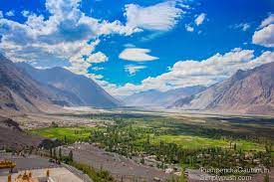

<https://mouryaaruntravels.com/uploads/package/f3389-ladakh.jpg>

2nd image:

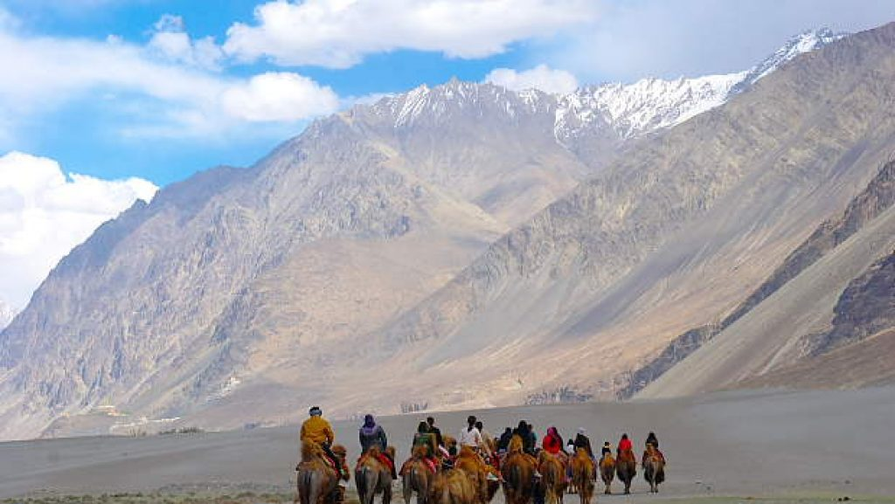

<https://cdn.s3waas.gov.in/s3291597a100aadd814d197af4f4bab3a7/uploads/bfi_thumb/2018081488-olw7rwxbvbsoa4018euoh9nfkws4ouekq8hopi8fii.jpg>